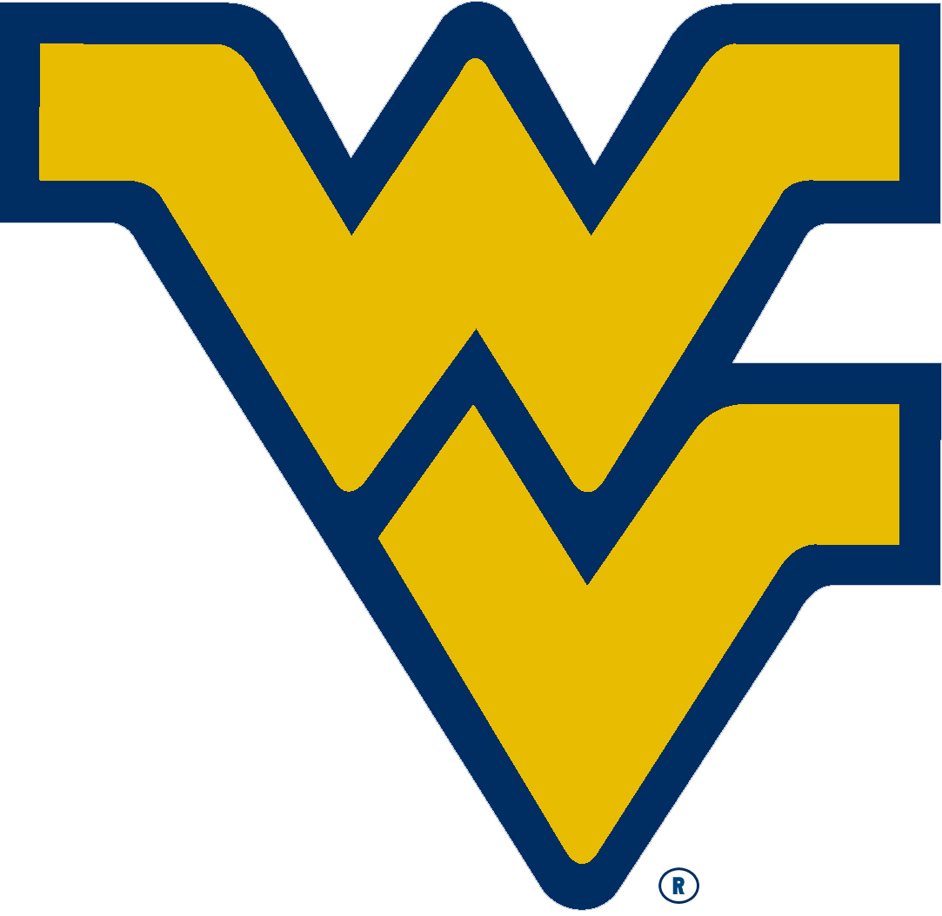
2016-2017 Fan Greetings at the WVU Coliseum

Contact Information:

Name:_________________________________________________

Address:_______________________________________________

City:______________________ State:_______ Zip Code:________

Phone:____________________ E-mail:______________________

Message:

Choose one: Happy Birthday Happy Anniversary Other ________

To: ____________________________________ (person receiving greeting)

Select Game for greeting to be displayed (circle one)

Nov. 11 Mount St. Mary’s Jan. 10 Baylor

Nov. 14 Mississippi Valley State Jan. 18 Oklahoma

Nov. 20 New Hampshire Jan. 24 Kansas

Nov. 28 Manhattan Jan. 28 Texas A&M

Dec. 10 VMI Feb. 4 Oklahoma State

Dec. 17 UMKC Feb. 11 Kansas State

Dec. 20 Radford Feb. 18 Texas Tech

Dec. 23 Northern Kentucky Feb. 20 Texas

Jan. 7 TCU Mar. 3 Iowa State

- Cost is $25.00 per greeting and payment type is personal or cashiers check only
- Make checks payable to WVU Department of Intercollegiate Athletics
- Payment must be received BEFORE any greeting will be displayed
- Form and payment must be received at least a week prior to the game in order for the greeting to be displayed
- Only a limited amount of greetings will be accepted per home game on a FIRST COME FIRST SERVE BASIS

Greeting will appear on the scoreboard three times during the game (subject to change)
Pre-game 8 min. timeout 1st half 8 min. timeout 2nd half

Print and Return this form to:
WVU Department of Intercollegiate Athletics
Attn: Athletics Marketing – Basketball Fan Greeting
P.O. Box 0877
Morgantown, WV 26507
(304) 293-3086

